Proposalfor 1Wembership

Benevolent and Protective Order of Elks of the United States of America

Proposer: 1 _

(Name of Proposer)
_
(Membership No.) (Signature of Proposer)

Address_:
_ City: _ State: Zip:
(Plus 4)

E-mail Address:

Proposes:
_

(M) (F)
Telephone Number: _

Legal name of applicant (Maiden) (circle one) Occupation Name of spouse Business name
Home address city, state & zip Business address Personal telephone number E-mail Business telephone

To Be Answered by the Applicant
- PLEASE PRINT OR TYPE -

E-mail

city, state & zip

- Applicant was born in the city of: _ _ County: _ _

State: Month:
_ Day:
_ _ Year:

- Do you believe in God and are you willing to attest to that belief? _ _ _ _ _
- Are you a citizen ofthe United States ofAmerica? _ _ _
- Ifforeign born, when and where were your final naturalization papers issued:

Month:
Day: Year:
_ _ at: --

- Are you willing to assume an obligation that:
  - Will not conflict with your duties to yourself; or your family, or your religious or political opinions, and that
  - Will bind you to uphold the Constitution and laws ofthe United States ofAmerica? _ _
- Are you now a member ofor directly or indirectly participating in the activities ofany group or organization, or supporting or adhering to beliefs or tenets advocating the overthrow of the Government of the United States or any of its political subdivisions by force or
violence? _ _

- Have you ever pled guilty or no contest to, or been convicted ot a felony or crime of moral turpitude? _
- (a) Have you ever served in the armed forces ofthe United States ofAmerica? _ _ _
(b) Ifyes, state the type ofdischarge and branch of service: _ _
- (a) Have you ever been proposed for membership in any Elks Lodge? _ _

(b) If yes, Lodge: _
_ Date: _
_ Result: _ _ _

- Have you been a bona fide resident within the jurisdiction of this Lodge immediately preceding the date ofthis application? _
- (a) Provide two references other than the Proposer All must be Members ofthe Order (Fill out form on back panel)
(b) List all places ofresidence and your occupation for the 5 years preceding the date of this application if different from the address and/or occupation given on reverse side. (Fill outform on backpanel)

EXCERPTS FROM LAWS OF THE ORDER
The Lodge Dues are per annum and may be paid semi-annually in advance ofApril 1st and October 1st of each year or annually in advance on April 1st of each year, as provided in the By-Laws of the Lodge An Applicant rejected must wait six months before reapplying for membership. Rejected Applicants shall have their Initiation Fees returned to them by the Lodge.
Should a Candidate fail, without good cause, to appear for Initiation within four months from the date of the Candidate's election, the Exalted Ruler shall declare the Candidate's right to Initiation (under such application and ballot) and also the Candidate's Initiation Fee forfeited
I understand that this application must be fully completed and accompanied by an initiation fee of$ . I further understand that pro-rata membership dues, for the current year, must be paid at the time of initiation

(Signature of Applicant) (Date)
Code 560700 Revised October 2013

[APPLICANT]
Check the Committee Preferences from the lists below:
CIVIC/COMMUNITY
[PROPOSER REFERENCES]
llA)· Provide two references other than the Proposer. All must be Members of the Order.
iEillERS. 1p••·.AI>PiIGJ\.TIQ

Amencamsm Blood Dnves
_ Boy/Girl Scouts
_Chanty
_Community Affairs,
_Community Welfare
_Drug Awareness
_Elks Hospitals/Clinics
_ Essay/Poster Contests
_ State Major Project Law and Order
Other _
_Scholarship
_Summer Camps Veterans Services Youth Activities
_Youth Sports
Name Membership_ No. Loctg_e Name & No.
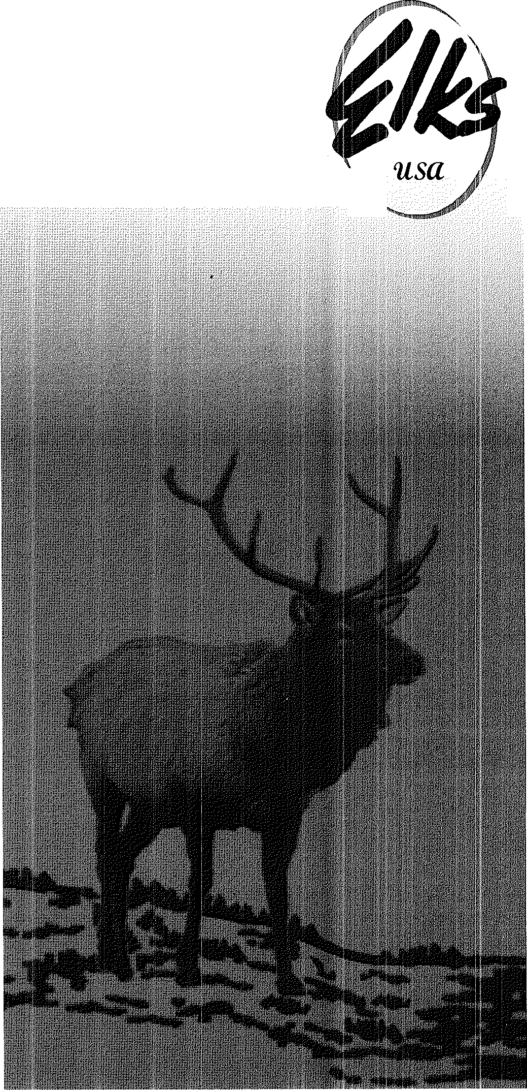Home Address Business Address Telep_hone E-mail Name Membership_ No. Loctg_e Name & No.
An Invitation to Join the Benevolent and Protective Order of Elks of the
United States of America
\
Home Address Busmess Address Telep_hone E-mail
List all places of residence and your occupation for the 5

LODGE ACTIVITIES
llB) years preceding the date o_f this application if different from
the address and/or occupation given on reverse side.

_Auditing/Financial
_Bingo
Breakfast/Dmners
_Bridge/Card Clubs
_ Building Mamtenance
_ Bus/Boat Tnps
Games Greeter
_ Lodge Bulletin
_ Lodge Visitation
_Membership
Other-------
Place of Residence: Date (Established/Changed): Occupat10n: Telephone: Place of Residence:
Date (Established/Changed): Occupat10n: Telephone:

_Chanty Fund-Raismg _Parties/Dances Convent10ns _Photography Decorations Public Relat10ns Entertamment _ State Major Project
_Elks National Foundat10n _Team Sports
_Family Activities Visitat10n of Sick
I would be mterested m servmg as an Officer of the

APPLICATION PROCESSING RECORD
Committee on Membership Recommendation
The undersigned Committee on Membership reviewed the appli- cation of for membership m the BPO Elks USA (Date) and found:
Favorably: Unfavorably: _ Signatures of Committee Members:

Lodge (Yes/No) _

[PROPOSER]

I understand that standards for becommg a Member of the Order of Elks are high, that membership 1s attamed by 111v1tatton only, and 1s limited to persons of good moral character who believe in God.
In proposmg this applicant for membership, I attest that I have known the applicant for (Months/Years),

To be completed by the Lodge Secretary
Result of Ballot by the Lodge: Accepted Rejected
Action | Date
Applicat10n Received
Initiat10n Fee Paid($ )
Read on the Lodge Floor
Balloting on Candidate by Lodge
Applicant Notified of Result of Ballotmg
Indoctrination
Prorated Dues Paid ($ )
Imtlated
Membership Number Assigned
Member Informat10n Entered in CLMS

that he/she 1s morally, socially and financially responsible; and, 111 my op1111on, will become an active Member who supports our beliefs.
In the event that the applicant 1s approved and accepted, I pledge my personal mterest to his/her development and progress m becommg an active Member who exemplifies the pnnc1ples of the Benevol,ent and Protective Order of Elks of the Umted States of Amenca.
Signature Membership Number (Date) _


" Share"

